Discussion of Conflict Handling in the Generic Connector Framework

So, far we have always considered the generic Connector read/write operations as asynchronous operations. That is the read from both ends start parallelly – or at least have no relation to each other.

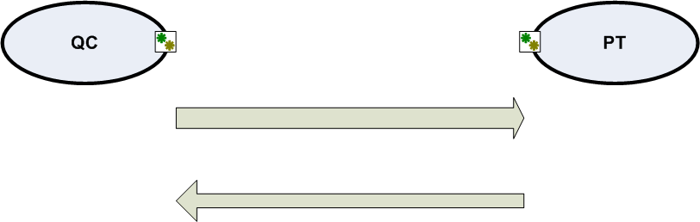

This makes conflict handling a trouble some feature. The various questions that needed answering were:

- How do we detect conflict?
- How do we handle conflict?
- How do we make sure the other end detects and resolves conflicts complementary to what one end does?

Towards, this end, various alternatives have been proposed.

- Maintain versions of the artifact changes and use that to detect conflict.
- Use timestamps of each change to detect conflict
- Ship oldvalue/newvalue pairs and use the old values to detect conflict in the target system

Each of the above solutions have drawbacks.

- Maintain versions of the artifact changes and use that to detect conflict.

Not all systems maintain versioning of the artifacts. In our current scenario,
SFEE (,Conigma?) maintain version numbers
PT, QC do not maintain version numbers – Artificial inclusion of version numbers is to be avoided as one of the goals of the GC design is to not add any house-keeping fields to either systems.

- Use timestamps of each change to detect conflict

Cumbersome. Also has to take into account that the source and target systems might be not only in two different timezones, but also be running two different absolute times. This might also involve introducing a new house-keeping field for some systems which is not preferred (refer point 1)

- Ship oldvalue/newvalue pairs and use the old values to detect conflict in the target system

A performance overhead, and there might be systems that may not be able to provide old values for a modification.

Make the flow aware of conflict handling:

Given the above issues, and that there might be users who need asynchronous behavior and there might be users who need conflict handling. For users needing conflict handling, we have to follow the below data-flow:

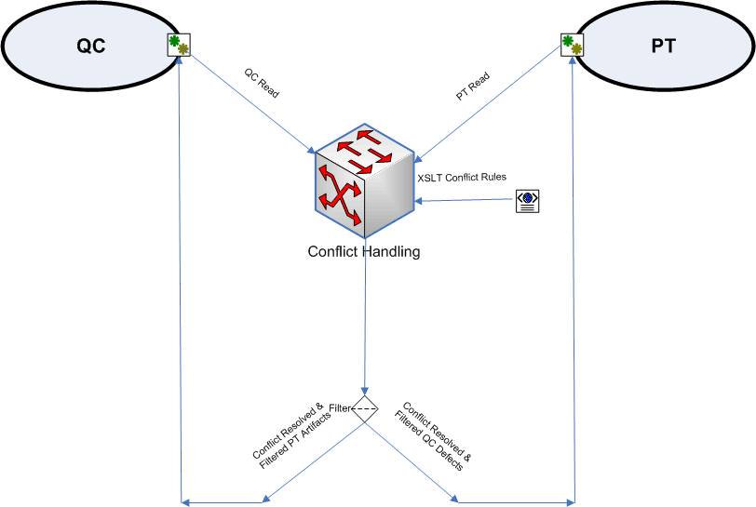

Where the conflict handling component is the recipient of the read output of both systems for a given run. The conflict handling component could be configured to operate based on xslt files, and the output records are filtered and sent to the appropriate components.

NOTE: Conflict handling might happen at two levels:
- Field level
- Attachment level

The conflict handling component should be aware of how to trigger conflict resolution by invoking the attachment interface (Details have to be worked out during the design/POC of the attachment interface)

